*Lab 3 - Testing Documentation*

The Burst Times = I have referred as Execution Time

**Test 1**

**Test case :** We have 6 processes with different execution times in no particular sorted order.

No inputs required.

Hard coded values are :

|  |  |  |
| --- | --- | --- |
| Process | Arrival Time | Execution Time |
| P1 | 0 | 10 |
| P2 | 0 | 3 |
| P3 | 0 | 6 |
| P4 | 0 | 4 |
| P5 | 0 | 2 |
| P6 | 0 | 7 |

***Output :***

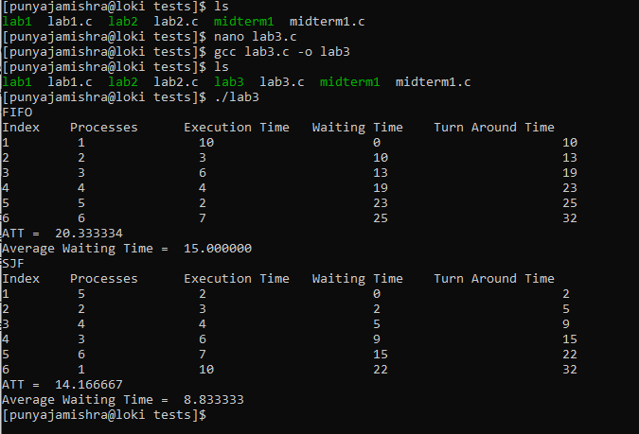

**For FIFO**

The processes run in the same order as entered, no changes. The calculations :

p1 TT = 10 + 0 =10

p2 TT = 3 + 10 = 13

p3 TT = 6 + 13 = 19

p4 TT = 4 + 19 =23

p5 TT = 2+ 23 = 25

p6 TT = 7+25 = 32.

Therefore the ATT = (TT for p1+p2+p3+p4+p5+p6/number of processes) = (10+13+19+23+25+32)/6 = 20.34. Similarly the average waiting time is just 0+10+13+19+23+25/6 = 15

**For SJF**

As we see, the processes are sorted in ascending order and the shortest will run first.

The index column shows the processes. The process column shows how the processes change order as per their execution time. Execution time is always ascending. The first process running always have 0 waiting time. Turn around time for each process is just execution time + waiting time.

p1 TT = 2 + 0 =2

p2 TT = 3 + 2 = 5

p3 TT = 4 + 5 = 9

p4 TT = 6 + 9 =15

p5 TT = 7+ 15 = 22

p6 TT = 10+22 = 32.

Therefore the ATT = (TT for p1+p2+p3+p4+p5+p6/number of processes) = (2+5+9+15+22+32)/6 = 14.67. Similarly the average waiting time is just 0+2+5+9+15+22/6 = 8.83

**Test 2**

**Test case :** Having all values already in ascending order – that is the CPU enter in ascending order of their execution time. I also decreased the number of processes and changed the execution time.

|  |  |  |
| --- | --- | --- |
| Process | Arrival Time | Execution Time |
| P1 | 0 | 2 |
| P2 | 0 | 3 |
| P3 | 0 | 5 |
| P4 | 0 | 9 |

*Output :*

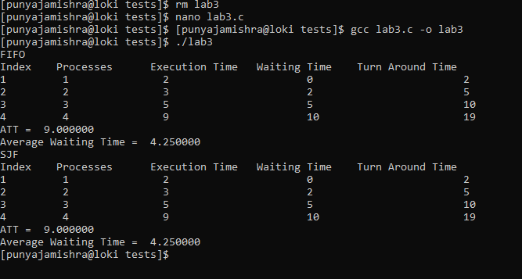

**For FIFO**

The processes run in the same order as entered, no changes. Turn around time for each process is just execution time + waiting time.

p1 TT = 2 + 0 =2

p2 TT = 3 + 2 = 5

p3 TT = 5 + 5 = 10

p4 TT = 9+10 = 19.

Therefore the ATT = (TT for p1+p2+p3+p4/number of processes) = (2+5+10+19)/4 = 9.

Similarly the average waiting time is just 0+2+5+10/4 = 4.25

**For SJF**

This is already in ascending order hence it runs in the same way for both FIFO and SJF. Turn around time for each process is just execution time + waiting time.

p1 TT = 2 + 0 =2

p2 TT = 3 + 2 = 5

p3 TT = 5 + 5 = 10

p4 TT = 9+10 = 19.

Therefore the ATT = (TT for p1+p2+p3+p4/number of processes) = (2+5+10+19)/4 = 9.

Similarly the average waiting time is just 0+2+5+10/4 = 4.25

**Test 3**

**Test case :** All CPUs have the same execution times

|  |  |  |
| --- | --- | --- |
| Process | Arrival Time | Execution Time |
| P1 | 0 | 5 |
| P2 | 0 | 5 |
| P3 | 0 | 5 |
| P4 | 0 | 5 |

*Output :*

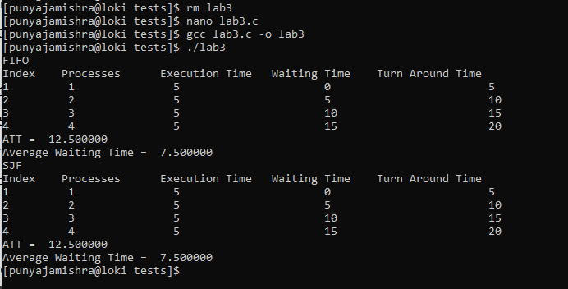

**For FIFO**

The processes run in the same order as entered, no changes. Turn around time for each process is just execution time + waiting time.

p1 TT = 5 + 0 =5

p2 TT = 5 + 5 = 10

p3 TT = 5 + 10 = 15

p4 TT = 5+15 = 20.

Therefore the ATT = (TT for p1+p2+p3+p4/number of processes) = (5+10+15+20)/4 = 12.5.

Similarly the average waiting time is just 5+10+15+20/4 = 7.5

**For SJF**

Again, all processes have the same execution time, so no sorting happens. Turn around time for each process is just execution time + waiting time.

p1 TT = 5 + 0 =5

p2 TT = 5 + 5 = 10

p3 TT = 5 + 10 = 15

p4 TT = 5+15 = 20.

Therefore the ATT = (TT for p1+p2+p3+p4/number of processes) = (5+10+15+20)/4 = 12.5.

Similarly the average waiting time is just 5+10+15+20/4 = 7.5

**Test 4**

**Test case :** Trying to see what happens if there is an invalid input like a character instead of int in the execution/burst time array. Also decreasing the number of processes to 3.

|  |  |  |
| --- | --- | --- |
| Process | Arrival Time | Execution Time |
| P1 | 0 | 5 |
| P2 | 0 | 5 |
| P3 | 0 | 5 |

*Output :*

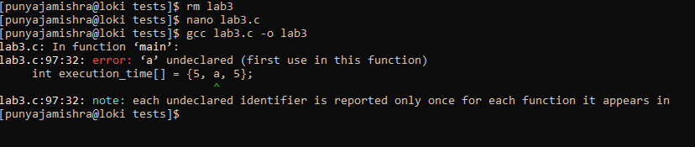

Well, it says error as it should. In short it did not run! :)

So everything runs smoothly.

I edited the C files in the loki itself for the various test scenarios.

In both cases I have included an Average Waiting Time. This is because I was not sure if we need it or not, but the reference material has it, so I was like, might as well.